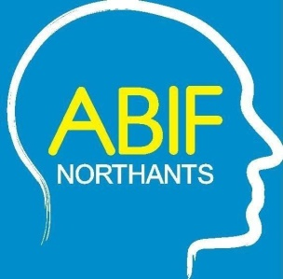
Northamptonshire Acquired Brain Injury Forum Conference

Wednesday 5th June 2023
Shoosmiths, 5 The Lakes, Northampton NN4 7SH

EXHIBITION STAND BOOKING FORM
If you wish to purchase a stand space at this conference please complete this form and return to:
Julie Allsopp c/o The Oakleaf Group, Ashton Road, Hartwell, Northampton NN7 2EY or email to julie.allsopp@oakleafcare.com

 | Exhibition Stand - Large max. 3m x 3m + 2 delegate spaces | £400
 | Exhibition Stand for Voluntary/Statutory Service + 2 delegate spaces | £FREE
 | Leaflet Insert in delegate bags only | £85
Do you require a table and chairs for your stand area? |  | YES / NO

ORGANISATION DETAILS
Contact Name
Organisation Name
Address including postcode

Email
Tel
Car Registration | This will be required if you need a parking space
Exhibition Stand Representatives | 1. | 2.

On receipt of this booking form you will be invoiced for the full amount if applicable. Alternatively, please make cheques payable to “ABIF Northants” and submit with this booking form.

If you want to pay by BACS the payment details are:

Bank Account: ABIF Northants
Sort Code: 77 21 02
Account Number: 17318868

Important: Your reference must be YOUR INVOICE NUMBER which will be provided on booking

