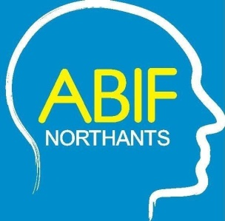
Northamptonshire Acquired Brain Injury Forum Conference

Wednesday 5th June 2024
Shoosmiths, 5 The Lakes, Northampton NN4 7SH

DELEGATE BOOKING FORM

Northamptonshire Acquired Brain Injury Forum are pleased to announce details of their forthcoming conference entitled:

“The changes in relationships and sexual intimacy that can occur after an acquired brain injury, what can help?”

To attend this one day conference please complete and return this booking form to Julie Allsopp c/o The Oakleaf Group, Ashton Road, Hartwell, Northampton NN7 2EY or email julie.allsopp@oakleafcare.com

COST

Professionals .................................... £50.00 each
Brain Injury Survivors/Family .......... £FREE
Students*.......................................... £FREE *please supply current Student ID No

Name of Delegate*
Job Title
Organisation
Address inc postcode
Email
Tel
Car Registration: | Please ensure you provide this to ensure you get a parking space
*If you require more than 1 delegate space please photocopy this form and complete for each delegate

On receipt of this booking form you will be invoiced for the full amount if applicable. Alternatively, please make cheques payable to “ABIF Northants” and submit with this booking form.

If you want to pay by BACS the payment details are:

Bank Account: ABIF Northants
Sort Code: 77 21 02
Account Number: 17318868

Important: Your reference must be your INVOICE NUMBER which will be advised on booking

If you have any special requirements i.e. wheelchair access, dietary etc. please state below:

